Devon Interfaith Forum 4 Youth
A Day of Building Bridges and Valuing Visions

Sunday 17th November 2019 11am – 4pm
at Lupton House and its gorgeous grounds in Brixham…
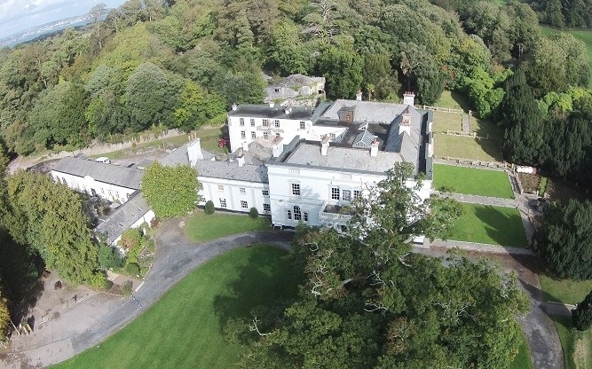

* A call out to all young people interested in making a difference and fighting back against bigotry, racism and prejudice
* A day of activities, workshops, visioning and planning for the future of a revived Interfaith Youth Project in the Devon area
* Free to attend, and Free Vegetarian Buffet Lunch

Please contact Marc at interfaithyouthproject@gmail.com for more info, and to reserve your place!

(Assistance with transport from Paignton Railway Station available)

